*Special thanks to Dan Berard and Andrea Hollenbeck for their collaboration in starting our placement night format. *

**Fundamental Belief:**

Every child has unique physical traits that will lead them to success on certain instruments. It is the music teacher’s job to have a process to guide students to these instruments

**Features:** Every child plays every instrument available to them in beginning band to see which instruments they have a physical aptitude towards.

**Benefits:** Students and parents are exposed to all beginning band instruments and learn through first-hand experience what each instrument sounds, looks, feels and smells like!

**Results:**  Student enjoyment and instrumentation! In a typical year my instrumentation is:

*Note:* *Our district does not start students on double reeds, bass clarinet or saxophones. Students interested in these instruments start on flute or clarinet and then may switch to these instruments with director permission.*

**Kinard Middle School Quick Hitters:**

1. Core Knowledge School (music required for 6th and 7th grade).
2. School of choice school with 760 students from 28 different elementary schools.
3. High performing school with high socio-economics.
4. Our goal is to have a non-competitive department amongst Band, Choir and Orchestra. Our numbers reflect this well: 240 Band students, 240 Choir Students, 160 Orchestra Students.
5. Poudre School District holds a three week summer music program to teach beginners how to play and care for their instruments (students must be placed prior to summer break).

**The Format**

Families go to my website and register for a time slot using a Google Doc Spreadsheet:

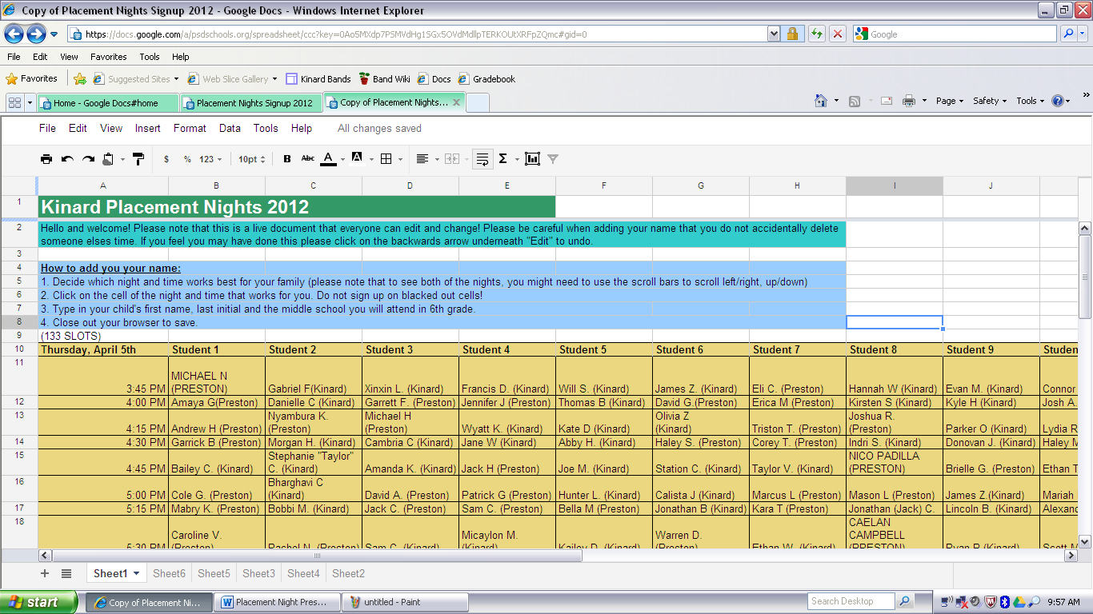

Each time slot has up to 10 students. Students spend 13 minutes (2 minute passing periods) in each instrument room learning how to form a basic embouchure from a professional musician. After playing on mouthpieces and instruments provided by local music stores, the professional musicians score each student on their aptitude for each instrument on a scorecard:

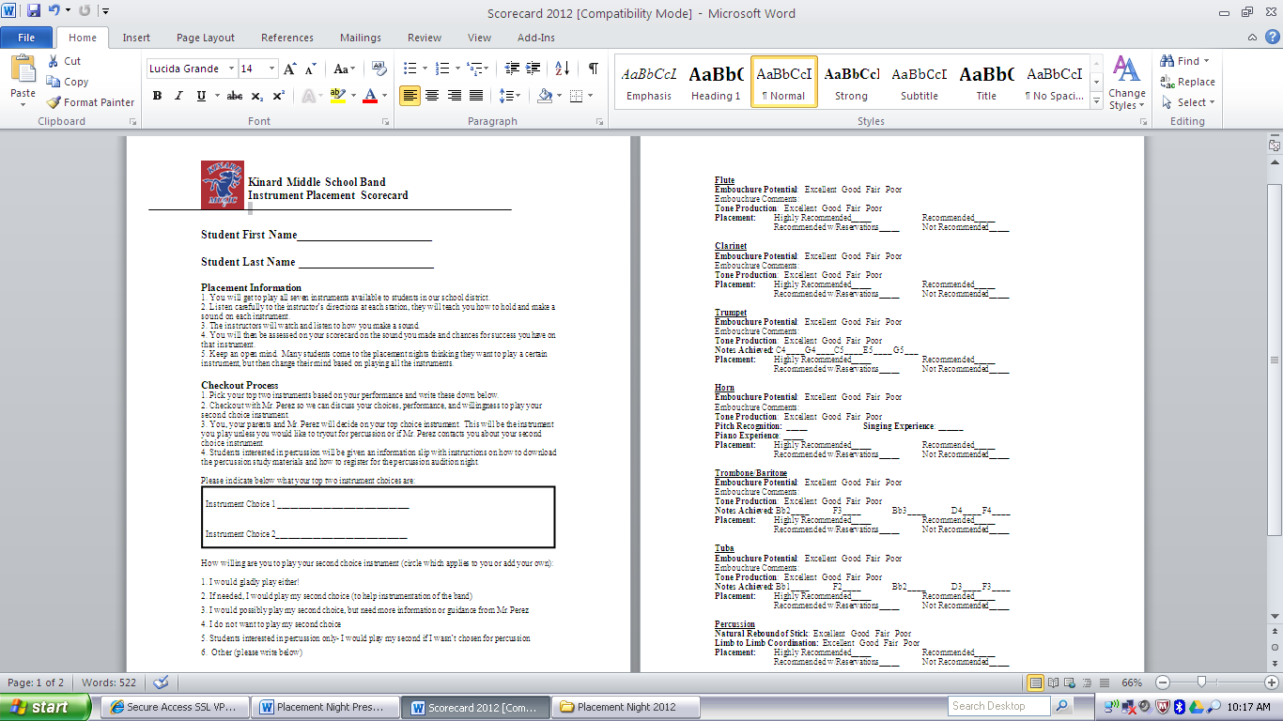

While students are participating in the rotations, parents watch an informational video on beginning band, fill out a Getting to Know You Form (below), read an Instrument Selection Guide (sample below), and meet with local music stores.

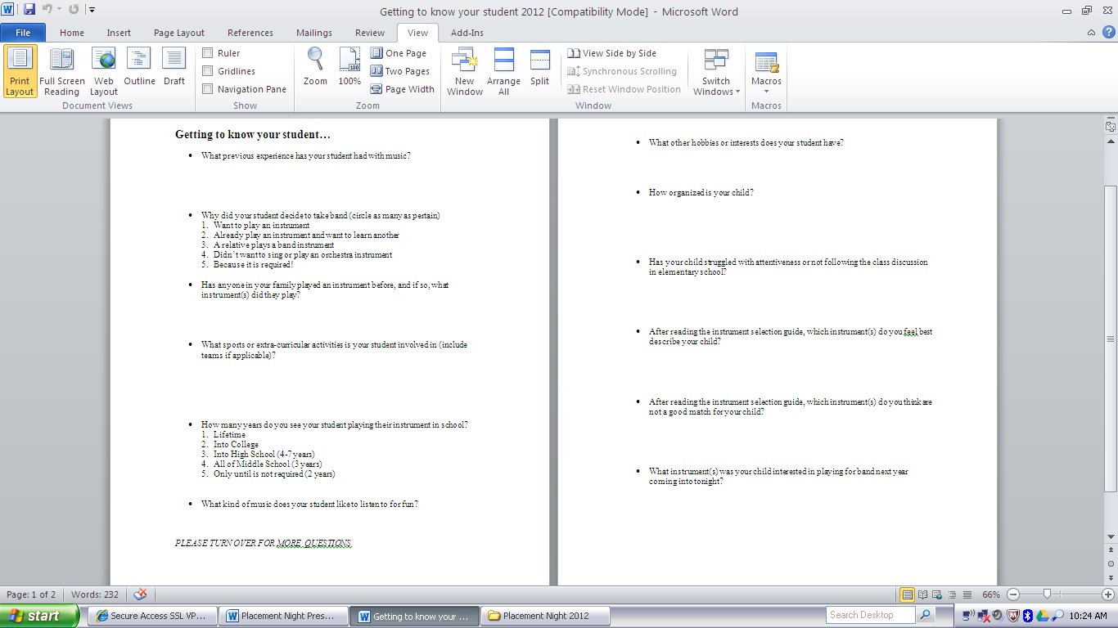

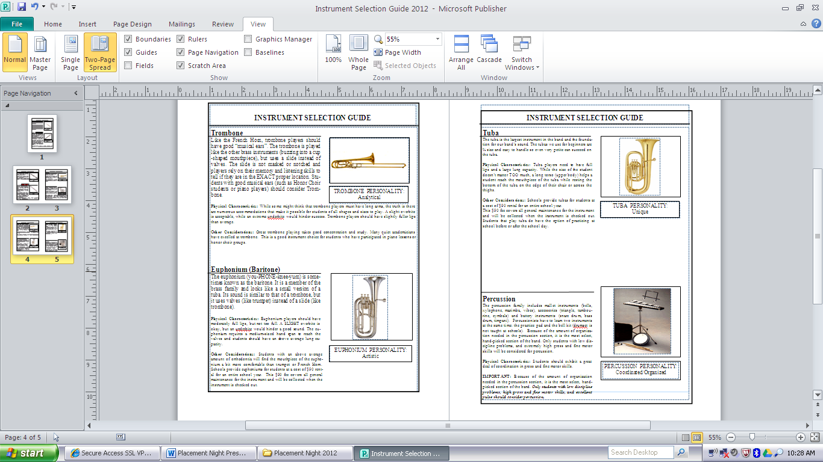

After completing the last rotation, students meet with their parents and pick their top two instruments based on their placement scores and the instrument selection guide. Families then check out with me to discuss their choices. I guide their final choice based on scores, first impressions and known instrumentation. I also get an idea of their flexibility with their second choice instrument (scorecard). In the case of horn, I ask families about their student's prior musical background and determination with challenging long term tasks. If a student is interested in percussion, I give them information on how to sign up for a percussion audition time (held a week later).

With the exception of percussion, the final decision is up to families!

**Timeline:**

**Percussion Placement Information:**

* Piano proficiency not required
* Students attend the regular placement night and the percussion audition night
* Students interested in percussion are tested on:

1. Stick Control/ Natural Rebound of the Stick
2. Hand to Hand Coordination
3. Limb to Limb Coordination
4. Inner Pulse and Tempo
5. Keyboard (piano) Note Recognition (provided with study materials)
6. Treble and/ Bass Clef Note Recognition (provided with study materials)

* Only the top 10 scoring students are selected for percussion
* Students that do not make the percussion section play their second choice instrument from the placement nights

*All documents included and mentioned in this presentation are available on my band website:*

**https://sites.google.com/site/perezband**